Dynamics modelling of WTR robots

I Modelling the robot
For WTR robots, consider 3 connected links on the plane, with for following parameters:
 | Link 1 | Link 2 | Link 3 | Link 4
Mass
Length
Joint
Center of mass distance
(w.r.t. head)
Center of mass
(w.r.t. head)
Center of mass
(w.r.t. world/base)
Inertia (w.r.t. CoM) | N/A
Green parameters are provided during design and considered as constants, blue parameters are derived parameters and are dependent of variables. Red parameters are the variables.
Associated frames and configuration are shown below:
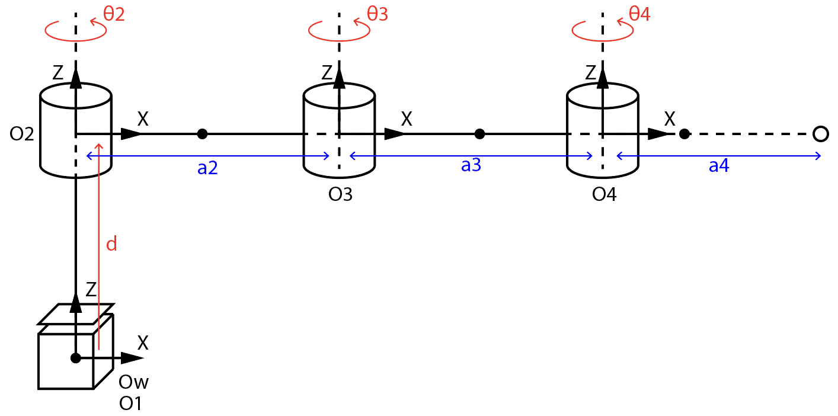
The corresponding modified DH parameters are:
i-th Joint |  |  |  |  | Type
1 | 0 | 0 |  | 0 | Prismatic
2 |  |  | 0 | 0 | Revolute
3 |  |  | 0 | 0 | Revolute
4 |  |  | 0 | 0 | Revolute
5 | N/A |  | N/A | 0 | N/A

II Deriving kinematic matrices
1. Using DH matrices
According to the modified DH convention, the transformation of a state in homogeneous coordinate is done by modelling the parameters sequentially:
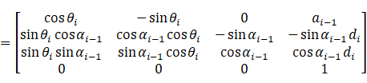
Note the 0-th DH parameter is considered to be zero.
Since for WTR/SCARA-type robots, we always have , can be simplified:
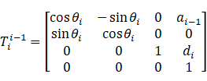
For all 4 joints, we have the total transformation matrix:
Or generally for the i-th link, the transformation matrix can be defined as:
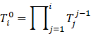
And for mass center defined in the local frame of each link, they can be transformed into world frame:
Deriving the mass center of each link is crucial for constructing the Lagrangian – we need the kinetic energy and potential energy for each link, which are usually defined around the link’s mass center.
2. Using direct geometrical calculation
Another way of deriving the mass center location is through the geometry of the robot, which involves no transformation matrices. This method can be intuitive for robots with only a few joints.
First, we derive position of the end point of each link:
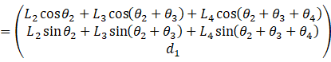
We can derive the center of mass w.r.t. the rotation axis (origin) of each link.
Combined we have the position of each mass center in the world frame:
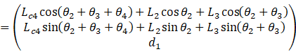
With the help of the CAS system in MATLAB we can verify the two methods yield the same result.

III Forming the Lagrangian
The Lagrangian is defined by , in which is the total kinetic energy of the system and is the total potential energy of the system. Physically the above energies can be defined using the object’s mass center:
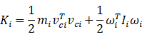
For WTR/SCARA-type robots, all joints rotate around their Z axis, therefore the second term can be simplified to only involving the joint velocity and the inertia around the Z axis at the mass center:
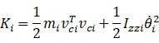
1. Kinetic energy using joint velocity
Since in the end we want the relationship between joint torque and joint position, velocity, acceleration, etc., it’s better to formulate kinetic energy in terms of the joint variables . This can be done by taking the derivative of mass centers w.r.t. joint variables, more specifically, joint velocities:
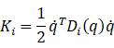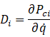
is called the inertia matrix of this link. The total kinetic energy is formed by summing individual kinetic energy of each link:
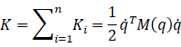
is called the mass matrix of the robot. As later we’ll see, this is one of the terms we want for calculating the inverse dynamics.
Deriving the mass matrix by taking derivatives can be a mess if you do it by hand. Instead, it can be done by utilizing link Jacobian:
The link Jacobian transforms the joint velocity to velocity of the link’s mass center in world frame.
Link Jacobian can be derived as:
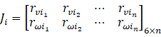
For revolute joints:
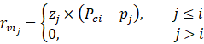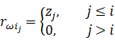
For prismatic joints:
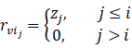
is the representation of Z axis of the j-th link in world frame, it’s also the third column of the rotation matrix part in the total homogeneous matrix up till this link: represents the origin of the j-th link, it’s also the translational part of the total homogeneous matrix up till this link.
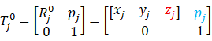
In total the link Jacobian provides the overall contribution of each joint to the i-th mass center in world frame. Utilizing the link Jacobian, link velocity and angular velocity is just:
In order to calculate energy, we need the inertia of each link to be represented in the world frame. This can be done by utilizing the rotation part of the total homogeneous matrix up till this link:
Finally, we can rewrite the kinetic energy in these terms:
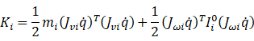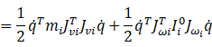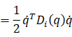
Among which:
And adding the above kinetic energy for all links we have the explicit form of total kinetic energy, also the mass matrix.
For the potential energy, it’s only related to gravity (no springs are involved):
2. Kinetic energy using Cartesian velocity
If you already derived the mass center location in analytical form, then the most intuitive way is to get velocity simply by taking its derivative w.r.t. time.
For later simplicity we calculate local direction of each link in world frame:
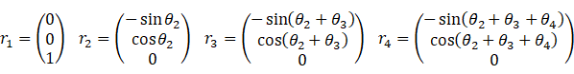
Mass center velocity can be seen as a combination of the above directions:
We then derive kinetic and potential energy for each link.
Kinetic energy (described per link as the combination of rotational and translational movement):
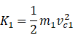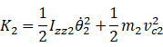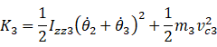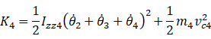
Potential energy:

IV Solving the Euler-Lagrange equation
Given Lagrangian , we have total generalized (non-conservative) force defined by the Euler-Lagrange equation:
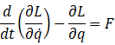
Inverse dynamics involves solving this equation for .
Since is a function of only, is also a function of only. This means the time derivative term can be expanded using chain rule:
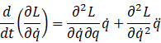
Which yields:
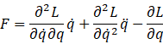
Since we have the Lagrangian in analytical form, we can calculate each of the derivatives effectively and accurately using the technique of reverse mode automatic differentiation.
Actually, the Hessian of Lagrangian w.r.t. general velocity is equivalent to the mass matrix , and one can directly notice that the above equation is the exact motion equation:
Where:
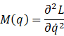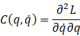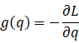
Note that in this direct method, the Coriolis and centrifugal matrix and gravity term is not unique, and it can be different from the same equation derived from other methods.

V Solving by Newton-Euler iteration
Recursive Newton-Euler iteration is another way of solving inverse dynamics. This method won’t provide the analytical form of the motion equation, but it avoids calculating derivatives. Using this method will take branch from step I, we solve for forces directly for each link.
Newton-Euler recursion is calculated in two passes: A forward pass that propagate joint velocity and acceleration from base to the end effector, and a backward pass that propagate forces/torques from end effector to joints.
1. Forward pass
Forward pass iteratively solves the linear and angular velocity/acceleration of the i-th joint using those of the (i-1)-th joint, starting from the base, where everything except for linear acceleration is zero.
Note that in this section the rotation matrix is the top-left block of the joint transformation matrix derived from modified DH parameters transposed. Normal transformation matrices are used to transform local vectors in the link frame back to the previous link frame, or to world frame, but here we need to transform forward. This will become non-trivial when we take the time-derivative of :
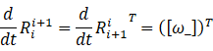
However since the joint rate is relative to the i-th joint, therefore we have:
For revolute joints:
Angular velocity can be derived as the angular velocity from the previous frame adding the contribution in this frame, which is brought by the joint velocity, always along the Z axis (by DH definition):
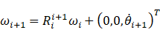
Angular acceleration is just angular velocity taking derivative w.r.t. time:
